**LAB 1 report**

In this lab we learn about installing these softwares, they are,

* Github desktop and Gitshell
* Zenhub plugin
* Creately account
* Web storm
* Brackets
* Node and Npm
* Ionic CLI

The following report shows the installation process of all these software,

1.Github desktop and gitshell:

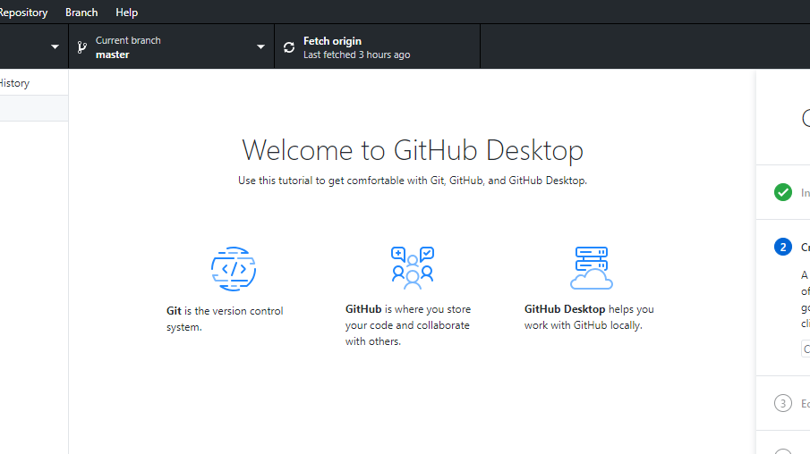

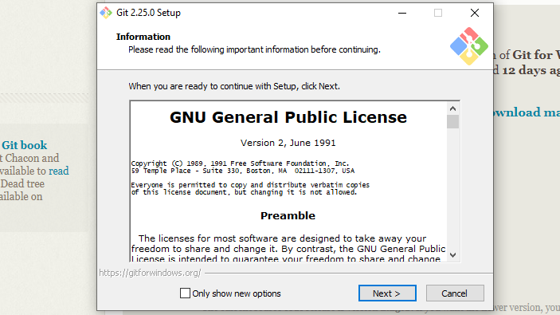

2. Installation of Zenhub:

Zenhub plugin is a extension,we can add this extension through our browser,we can use zenhub that readily available in github.

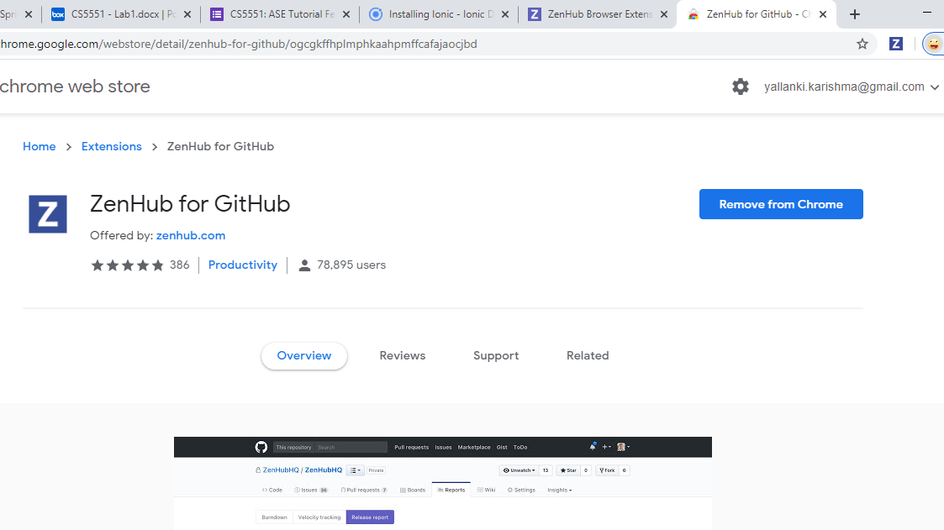

3.Creately:

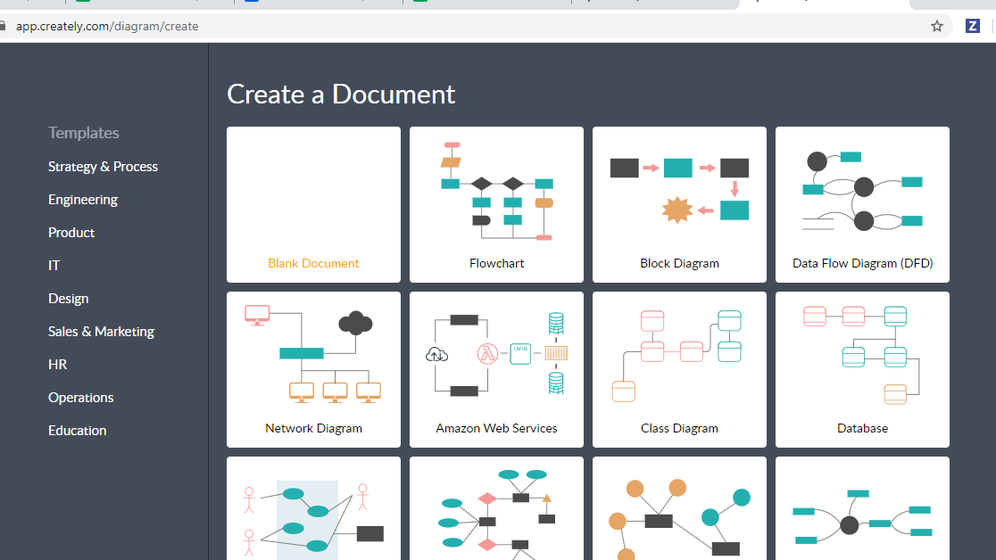

4.webstorm:

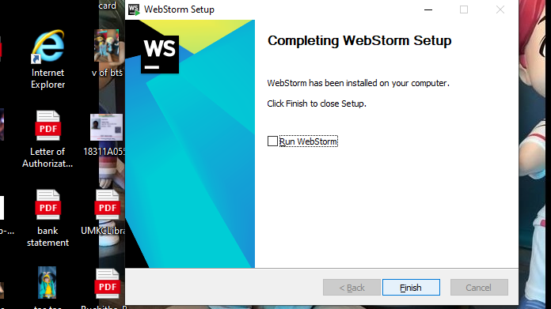

5.Brackets:

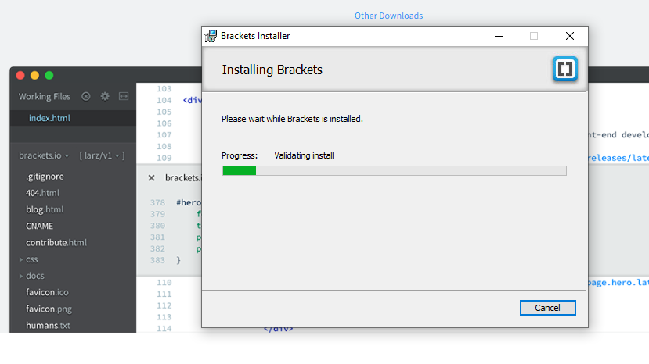

6. Node and Npm and Ionic CLI:

After installing node.js, we can check the status of installation of ionic and npm and node through following commands as shown.

